**5阶段流水线CPU的实现报告**

本次实现是在王华老师的《计算机系统结构综合实验》实验4的代码的基础上实现的，数据冒险通过数据前推和暂停解决，控制冒险通过ID级检测解决。在此基础上实现了

1. **MIPS32 release6中的R型，I型，J型共59条指令**
2. **外设Keypad的Input和七段数码管的Output**
3. **对中断，系统调用，未实现指令，以及溢出的中断或异常的处理**

其中中断或异常的控制的实现参考了李亚民老师的《计算机原理与设计:Verilog HDL版》中第六章对单周期CPU中断或异常处理的实现

实验的代码：[shwhwhwh/system_exp (github.com)](https://github.com/shwhwhwh/system_exp)

**实现指令共59条（不包括中断相关指令）**

以下实现指令参考MIPS 32 release6中的指令和伪指令

**R型指令，共22条**

**加减操作，共4条**

1. add
2. addu
3. sub
4. subu

**需要考虑的新增控制信号**

uns：指令为addu 和 subu时为1，此时alu在进行加减运算时不考虑溢出，否则考虑溢出

**逻辑操作，共4条**

1. nor
2. or
3. and
4. xor

**跳转，共1条**

1. JR

**需要考虑的新增控制信号**

1. jr：当指令为JR或JALR时，该信号为1，表示跳转的地址来自寄存器

**乘法，共4条**

1. mul
2. muh
3. mulu
4. muhu

**需要考虑的新增控制信号**

1. uns ：当指令为mulu和muhu时为1，此时alu在进行乘法时，会进行无符号的乘法，否则进行有符号的乘法

**特殊指令，共1条**

1. nop

**移位指令，共6条**

1. sll
2. sllv
3. sra
4. srav
5. srl
6. srlv

**需要考虑的新增控制信号**

无

**比较指令，共2条**

1. slt
2. sltu

**需要考虑的新增控制信号**

1. uns ：指令为sltu 时为1，alu 中进行无符号的less than 比较，否则进行有符号的比较

**总结**

R型指令需要新增的控制信号只有jr 和uns

**I型指令，共34条**

**加法操作，共1条**

1. addiu

**需要考虑的新增控制信号**

1. uns ：为1，alu进行加法操作时不考虑溢出

**逻辑操作，共3条**

1. andi
2. xori
3. ori

**需要考虑的新增控制信号**

无

**非紧凑控制指令，共9条**

1. b
2. bal
3. beq
4. bgez
5. bgezal
6. bgtz
7. blez
8. bltz
9. bne

**需要考虑的新增控制信号**

1. al ：保存返回地址控制信号，为1时将PC + 8 保存到31号寄存器r31中
2. compact ：控制指令是否是紧凑指令，为0，有延迟槽，即控制指令的后一条指令不会被置为NOP，而是继续执行

**紧凑控制指令，共10条**

1. blezc
2. bgezc
3. bgec
4. bgtzc
5. bltzc
6. bltc
7. bgeuc
8. bltuc
9. beqc
10. bnec

**需要考虑的新增控制信号**

1. uns ：指令为bgeuc和bltuc时为1，进行无符号比较
2. compact ：为1，没有延迟槽，在控制语句条件成立时，需要将下一条指令置为NOP

**内存读取，共6条**

1. lb
2. lbu
3. lh
4. lhu
5. lui
6. lw

**需要考虑的新增控制信号**

1. uns：指令为lbu lhu 时为1，读取的结果进行0拓展
2. half ：指令为lhu lu时为1，读取内存地址所存的word的低16位，然后在后面补16位0
3. is_byte：指令为lb lbu时为1，读取内存地址所存的word的低8位，然后在后面补24位0 （不用byte是因为它是关键字！！！）

**内存写入，共3条**

1. sb
2. sh
3. sw

**需要考虑的新增控制信号**

1. half：解释类似内存读取中的half
2. is_byte ：解释类似内存读取中的is_byte

**比较指令，共2条**

1. slti
2. sltiu

**需要考虑的新增控制信号**

1. uns ：同R型sltu中的uns

**J型指令，共3条**

1. j
2. jal
3. jalr
4. （还有一个jr在R型指令中）

**需要考虑的新增控制信号**

1. al ：同I型指令中bal等指令的al，指令为jal jalr时为1
2. jr：同R型指令中jr指令的jr，指令为jalr时为1

**仿真测试**

**单条指令的仿真测试**

经过测试，上述单条指令均能正常执行

**仿真图**

**R型**

1. add

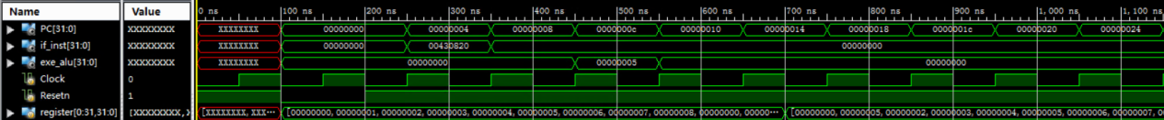

1. addu

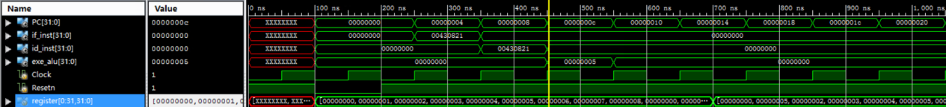

1. and

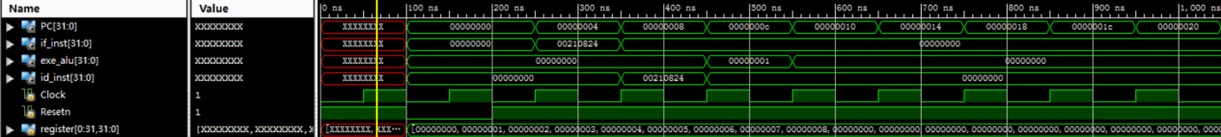

1. jr
2. jr_inst

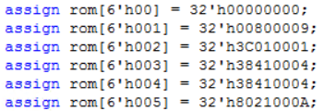

1. jr r4

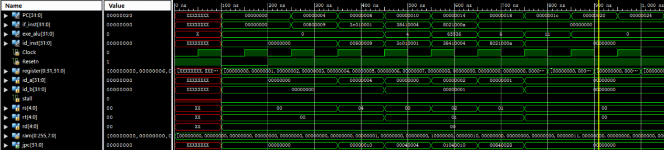

1. muh



1. muh_neg6



1. muhu_neg2_neg3



1. mul

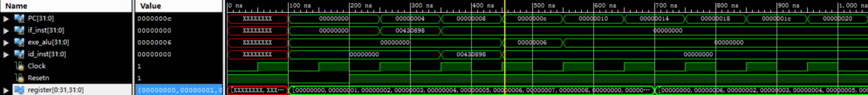

1. mul_neg2_neg3



1. mul_neg6



1. mulu
2. mulu_neg2_neg3



1. nor

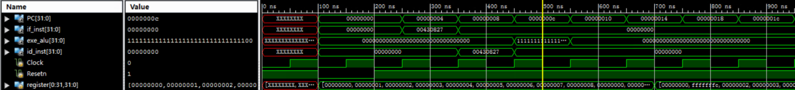

1. or

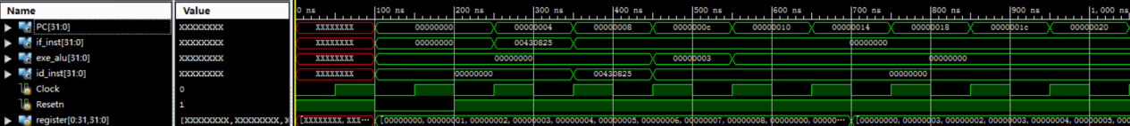

1. sll

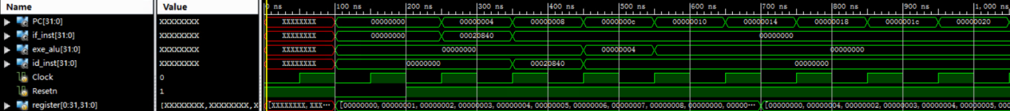

1. sllv

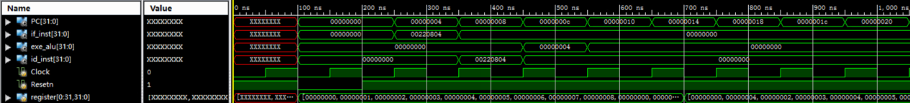

1. slt
2. slt_neg2_3

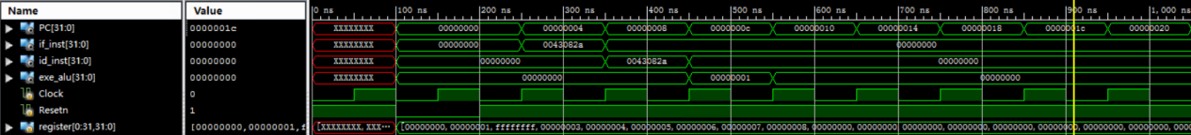

1. sltu
2. sltu_neg2_3

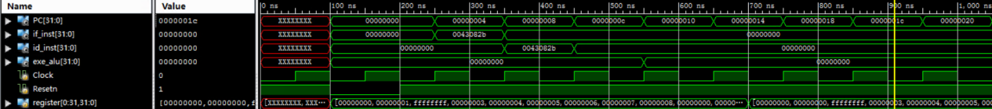

1. sra

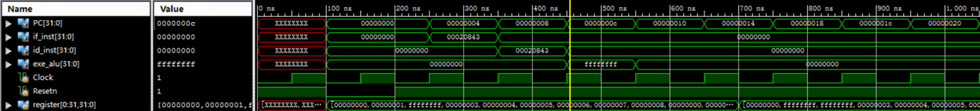

1. srav

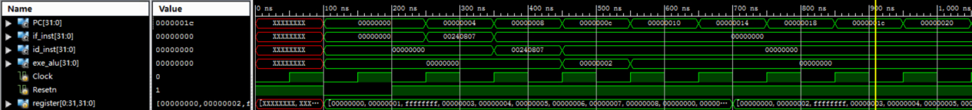

1. sub

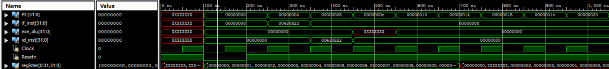

1. subu

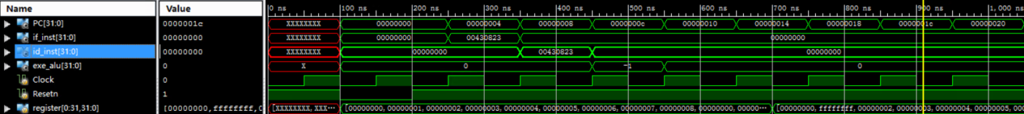

1. xor

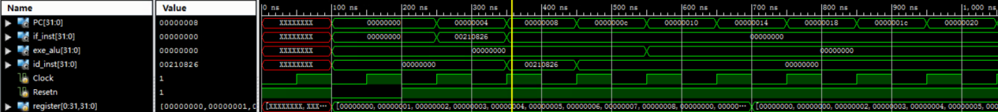

**I型**

1. addiu_2_neg3

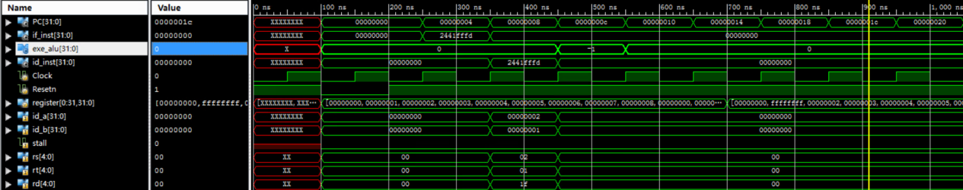

1. andi

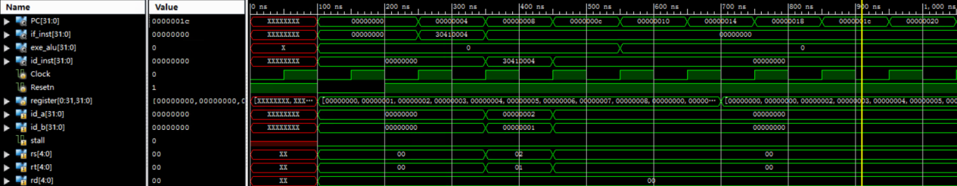

1. ori

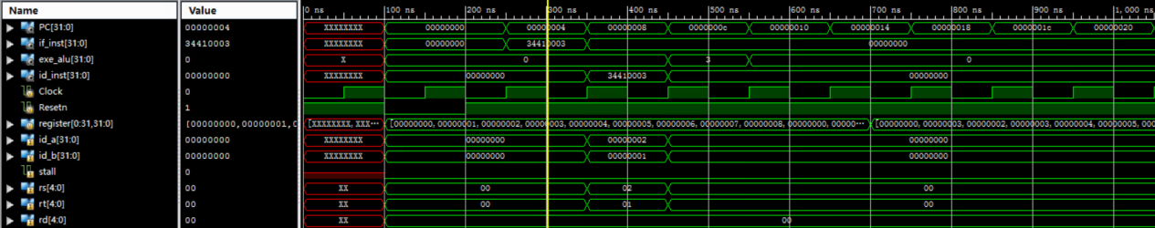

1. xori

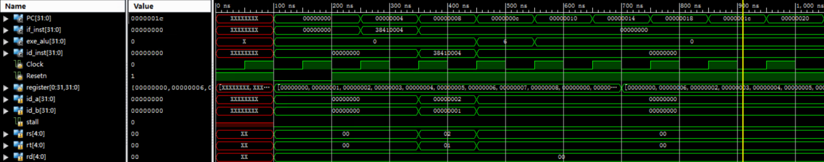

1. lb

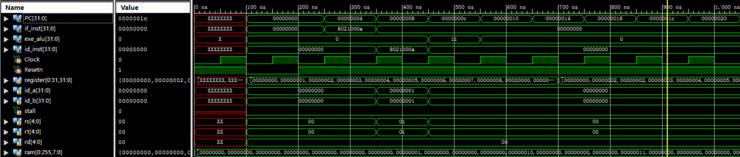

1. lbu_r1_10(r1)(10000010)

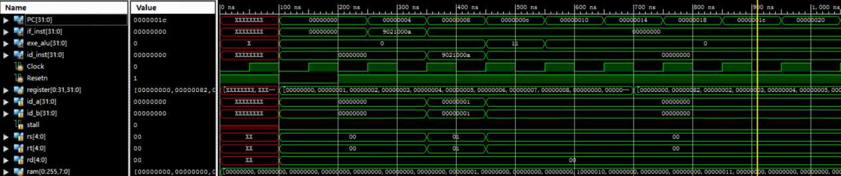

1. lb_r1_10(r1)(10000010)

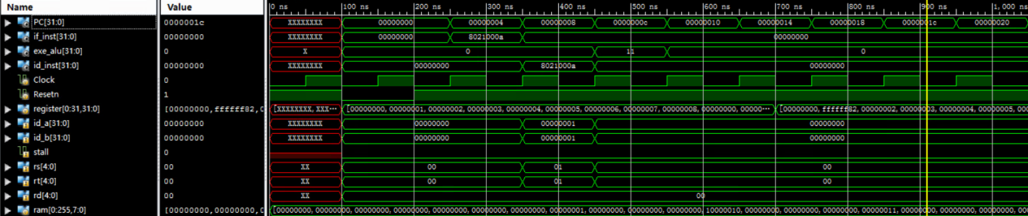

1. lh
2. lh_r1_10(r1)(0x8002)

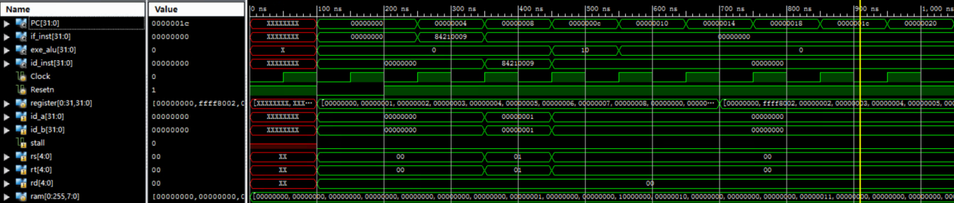

1. lh_r1_9(r1)(0x0002)

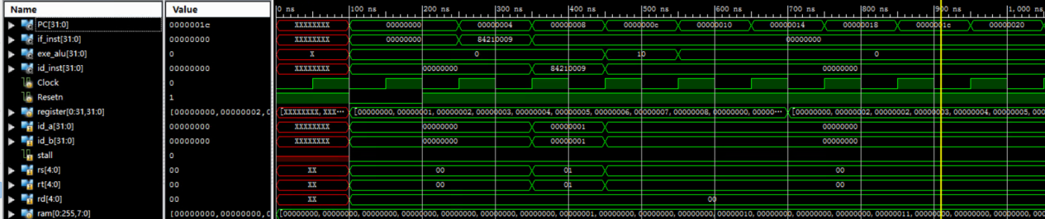

1. lhu
2. lhu_r1_9(r1)(0x8002)

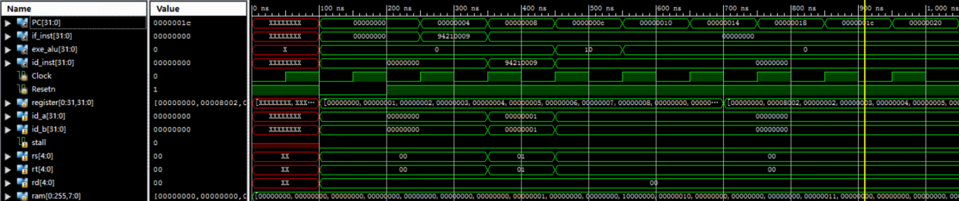

1. lui_r1_1

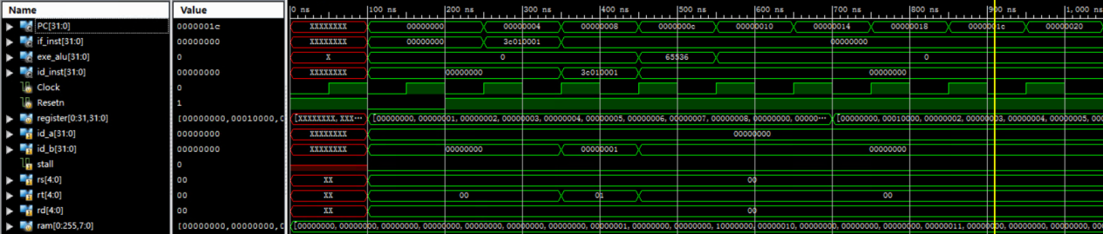

1. lw_r1_10(r1)(0x8002)

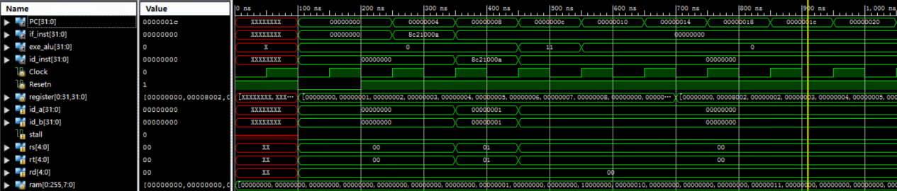

1. sb_r1(0x1)_3(r1)

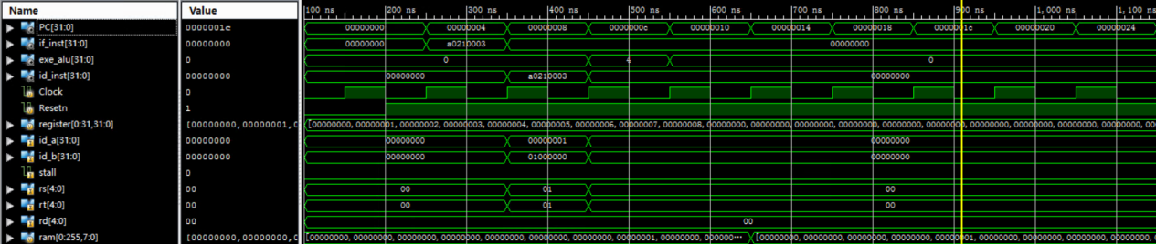

1. sh_r1(0x1)_3(r1)

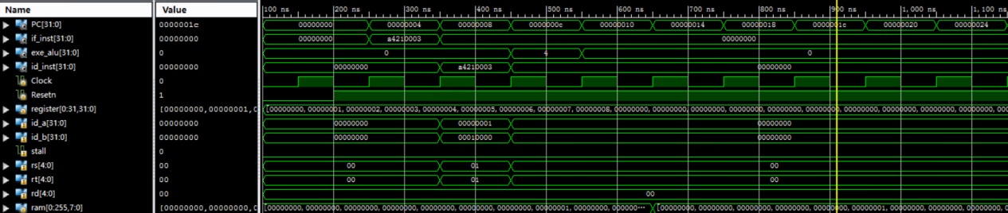

1. sw_r1(0x1)_3(r1)(0x1)

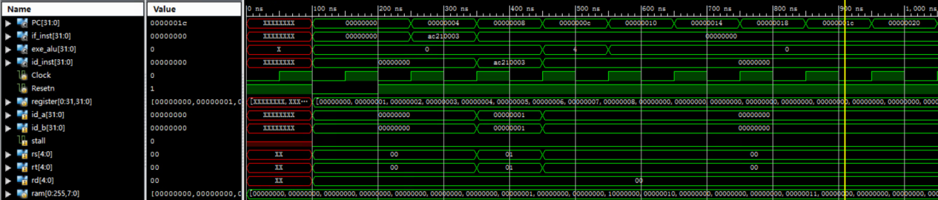

1. slti_r2_neg3

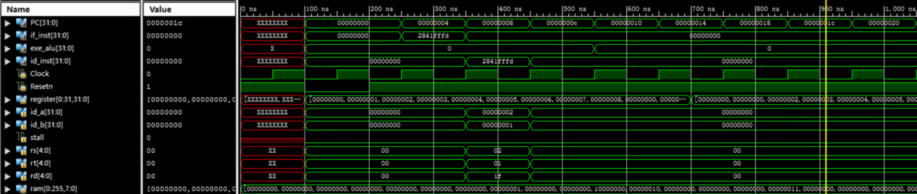

1. sltiu_r2(0x2)_neg3

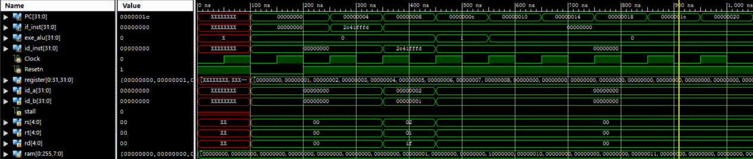

1. beq
2. beq_r1_r1_3

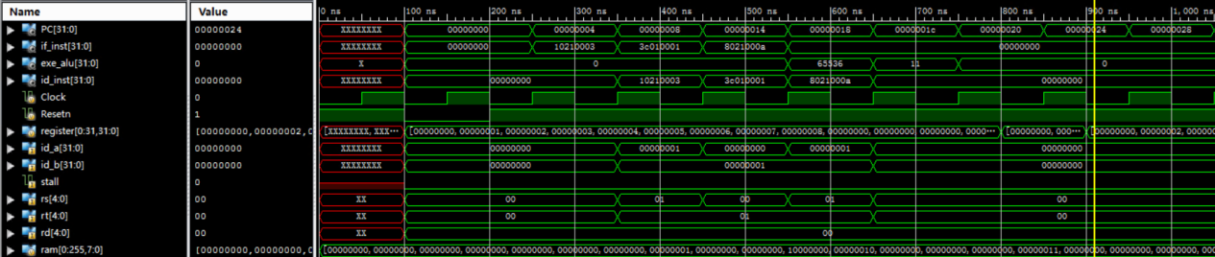

1. beq_r1_r1_3_insts

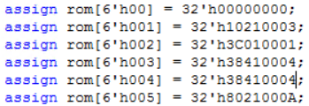

1. bgez

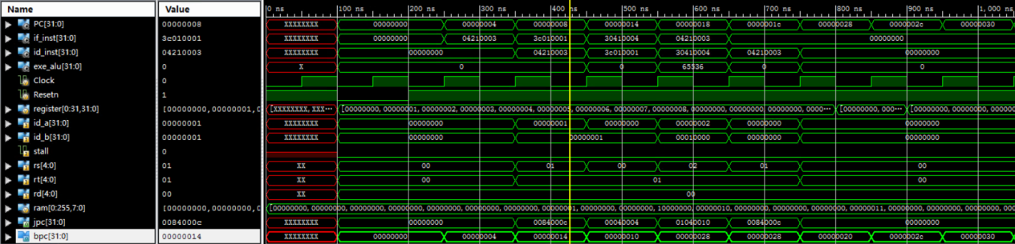

1. bgez_insts(后续的insts除了控制指令都是相同的)

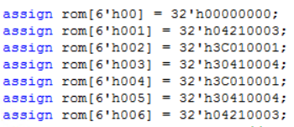

1. bgezal

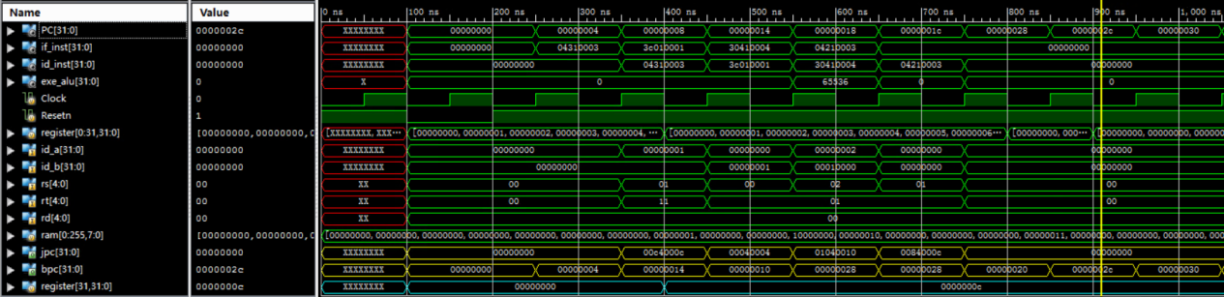

1. bgtz_r1,_3

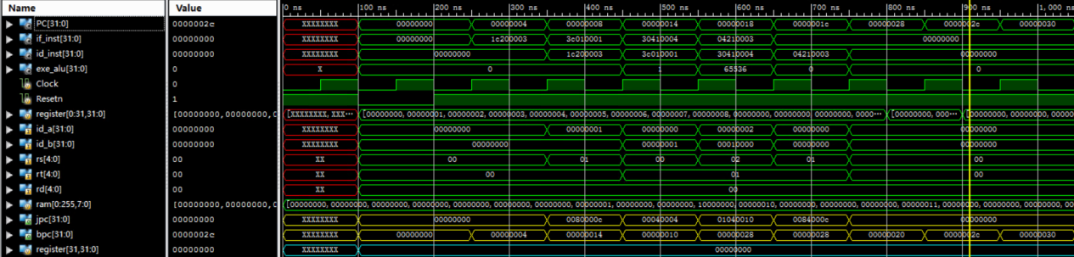

1. blez_r0_3

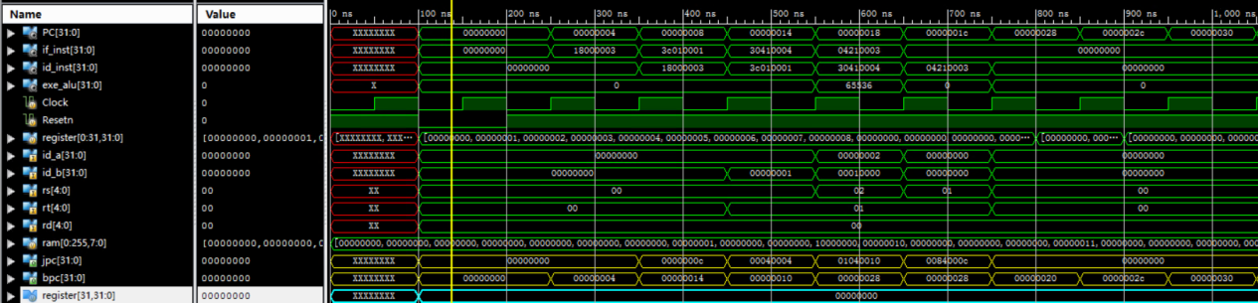

1. bltz_r1(-1)_3

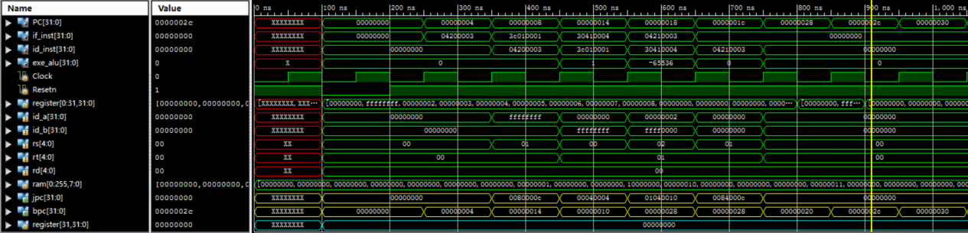

1. bne_r1(1)_r2(2)_3

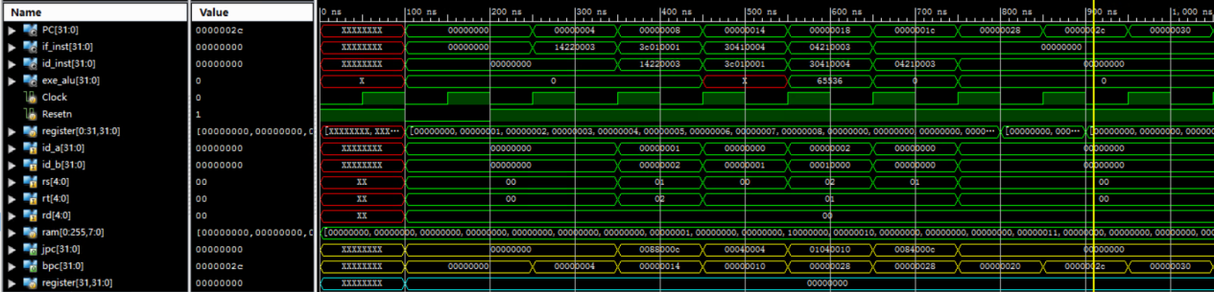

1. blezc_r1(0)_3

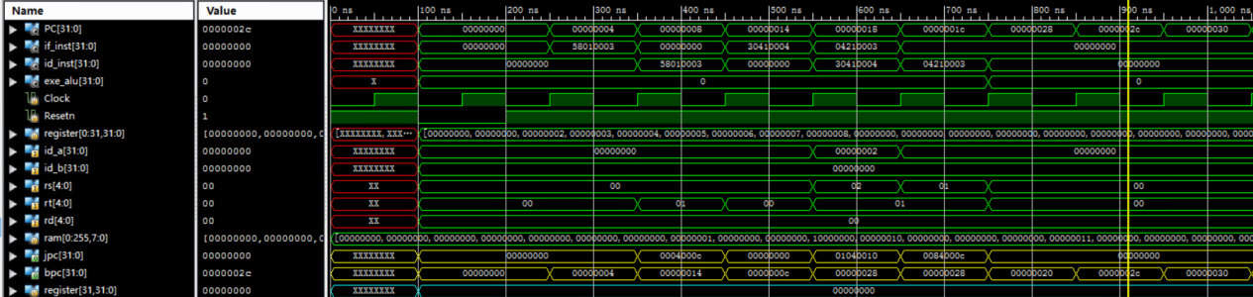

1. bgezc_r2(2)_3

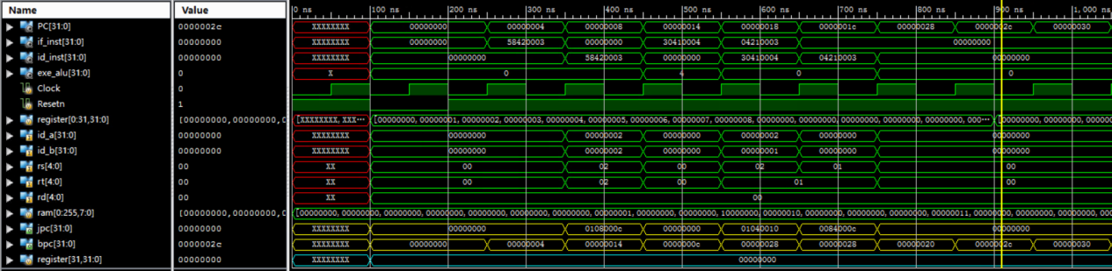

1. bgec_r2(2)_r1(1)_3

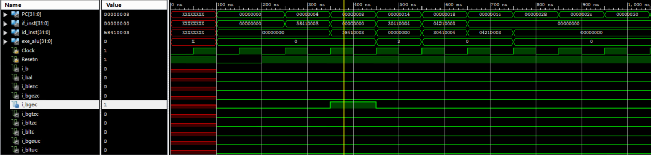

1. bgtzc_r1(1)_3

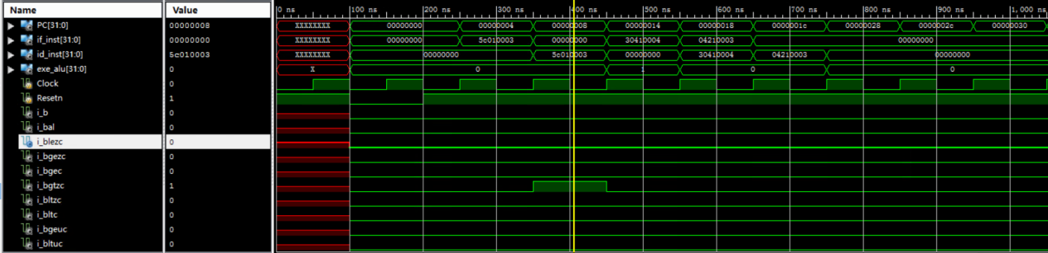

1. bltzc_r1(-1)_3

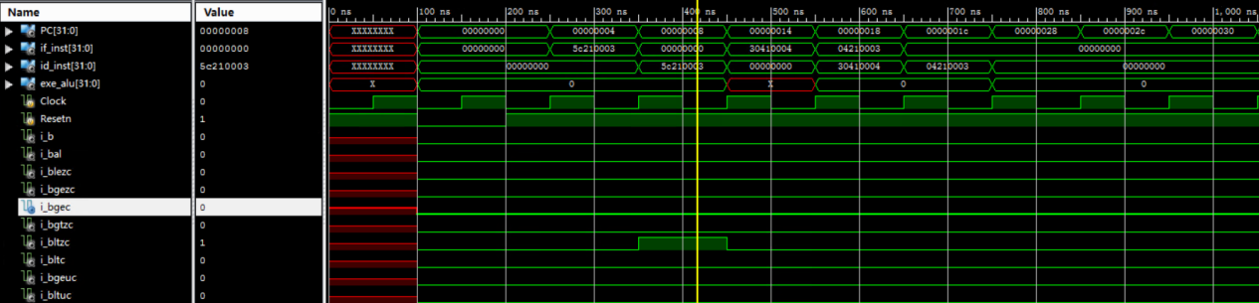

1. bltc_r1(1)_r2(2)_3

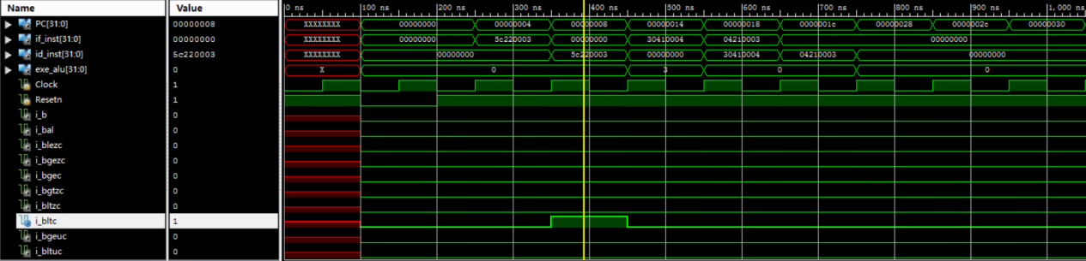

1. bgeuc_r1(-1)_r2(2)_3

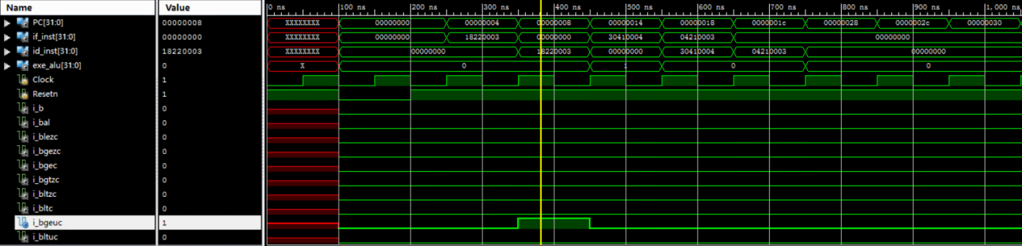

1. bltuc_r2(2)_r1(-1)_3

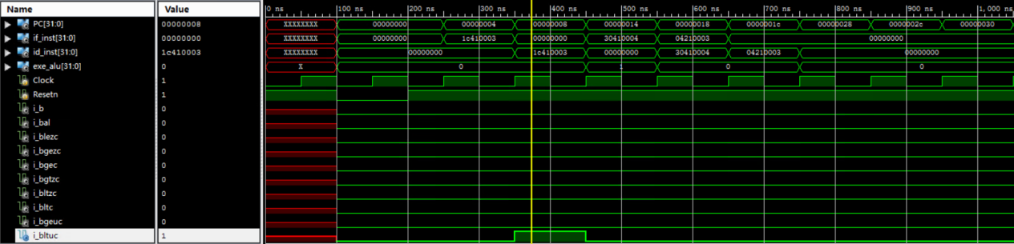

1. beqc_r1(2)_r2(2)_3

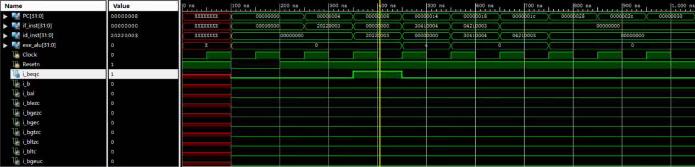

1. bnec_r1(1)_r2(2)_3

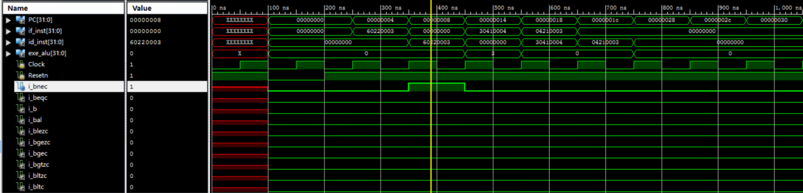

1. b_3

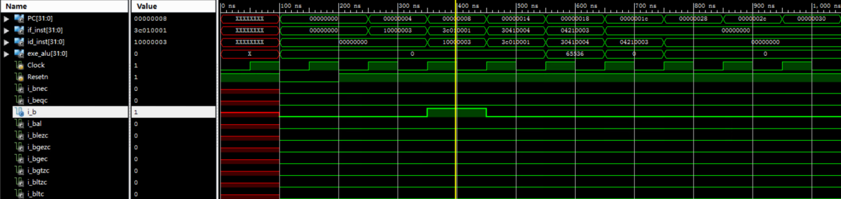

1. bal_3

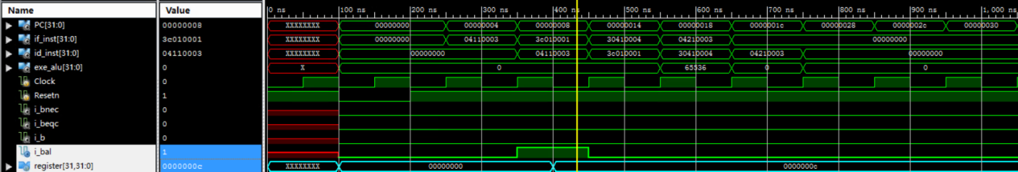

**J型**

1. j 4

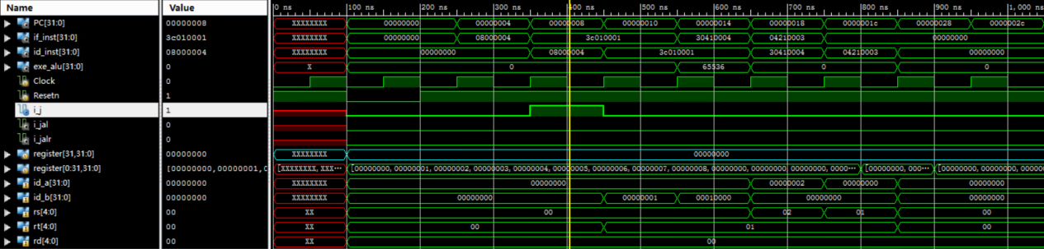

1. jal_4

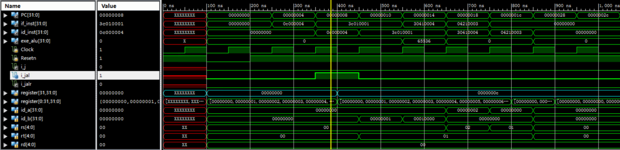

1. jalr_r4(4)

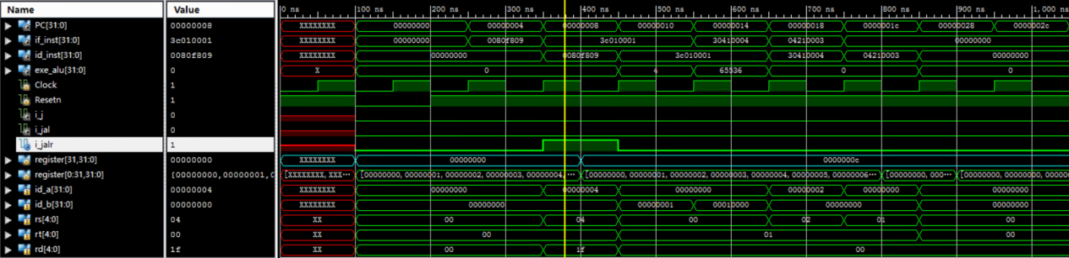

1. jalr_r4_r1

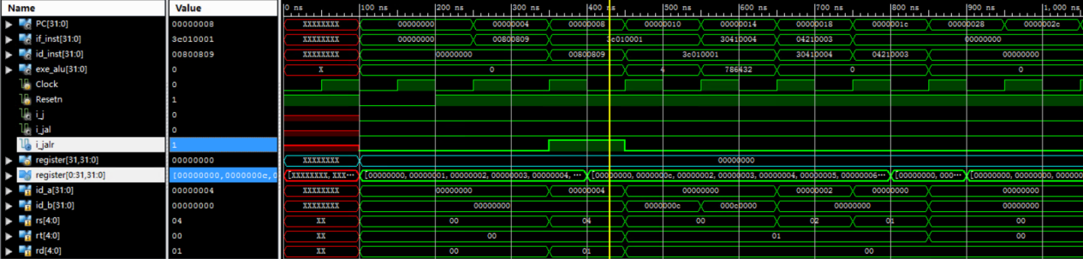

**多条指令的综合测试**

**指令序列**

|  |
| --- |
| Assembly language addu r1, r1, r2 //r1 = 3 or r1, r1, r4 //r1 = 7 mul r1, r1, r3 //r1 = 21 subu r1, r8, r1 //r1 = -13(FFFF FFF3) srl r9, r1, 4 //r9 = 0FFF FFFF jr r8 sra r1, r1, 4 //r1 = FFFF FFFF(-1) slt r10, r1, r9 //r10 = 1 addiu r11, r1, 2//r11 = 1 beqc r10, r11, 1//跳转成功 addiu r11, r1, 2//不执行，被置为NOP lw r1, 3(r4) //r1 = 1 sw r1, 3(r8) //ram[11] = 1 jal 1 |

**仿真图**

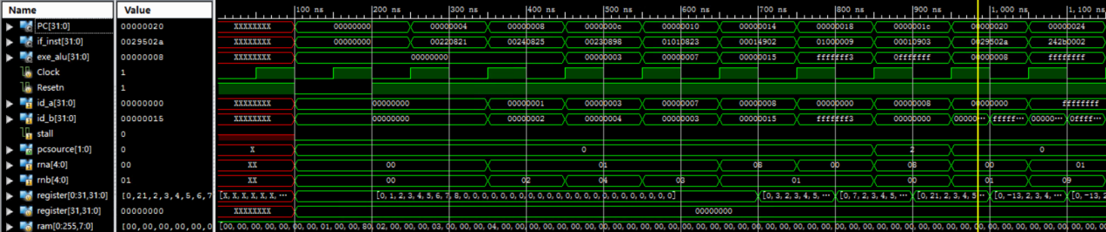

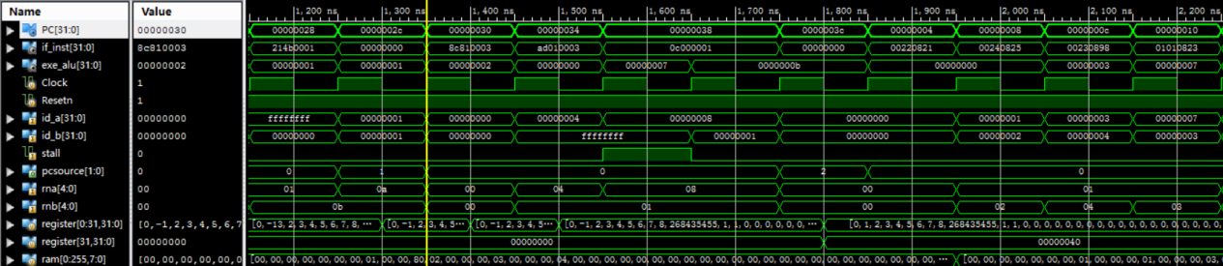

仿真结果与上述指令序列中的预期结果相同，通过该仿真综合测试

**外设Keypad的Input和七段数码管的Output**

本实现是在学习邓建老师的代码后，通过把前述的流水线CPU作为一个模块，在顶层模块中调用Keypad和7段数码管以及流水线CPU来实现IO的，以下是相关的代码：

主要的变动是将memout的赋值放到了SCCPU模块中，然后通过SCCPU模块输出memout

**顶层模块代码pipelinedcpu_anvyl**

|  |
| --- |
| Verilog `timescale 1ns / 1ps module pipelinedcpu_anvyl (  CLK100MHZ,  SW,  BTN,  LED,  SEG,  AN,  KYPD_ROW,  KYPD_COL );  input CLK100MHZ;  input [7:0] SW;  input [3:0] BTN;  output [7:0] LED;  output [6:0] SEG;  output [5:0] AN;    input [3:0] KYPD_ROW;  output [3:0] KYPD_COL;   //clock signal  wire clock = CLK100MHZ;  wire resetn = ~BTN[3];  wire cpu_clock, mem_clk;  // reg [31:0] memout;  wire [31:0] mb, malu;   //IO  wire [31:0] mapped_io_out;   wire [7 : 0] IO_7SEGEN_N;  wire [31 : 0] IO_7SEG_DATA;   wire [7:0] keypad_data;   /*intr*/  wire intr, inta;  /*intr*/   clock_generator clock_generator_0 (  .Clock_100M(clock),  .Clock_1M (cpu_clock),  .Clock_2M (mem_clk)  );   wire divided_clock;  ClockDivider M1_ClockDivider (  .Reset(1'b0),  .Clock(CLK100MHZ),  .DividedClock(divided_clock)  );   wire [7:0] SevenSegsAndPoint;  assign SEG = SevenSegsAndPoint[6:0];   SevenSegsController M2_SevenSegsController (  .Reset(1'b0),  .Clock(divided_clock),  .DisplayEnables(~IO_7SEGEN_N[5:0]),  .Data(IO_7SEG_DATA[23:0]),  .SevenSegsAndPoint(SevenSegsAndPoint),  .ShowOneofSix(AN)  );   Keypad Keypad_Device (  .Reset_N (resetn),  .Clock (divided_clock),  .Row (KYPD_ROW),  .Col (KYPD_COL),  .KeypadData(keypad_data)  );   wire [31:0] PC, if_inst, id_inst, exe_alu;  SCCPU pipelined_cpu(  /*intr*/  .intr(intr),  /*intr*/  /*IO*/  .keypad_data(keypad_data),  .mapped_io_out(mapped_io_out),  /*IO*/  .Clock(cpu_clock),  .Mem_Clock(mem_clk),  .Resetn(resetn),  .PC(PC),  .if_inst(if_inst),  .id_inst(id_inst),  .exe_alu(exe_alu),  .mem_alu(malu),  .mem_wmem(mwmem),  .mem_b(mb)  /*intr*/  , .inta(inta)  /*intr*/  );  assign intr = (malu[31:16] == 16'h_BF80 && malu[4:0] == 5'b_1_0100) ? 1'b1 : 1'b0;   mapped_io_data mapped_io_mem (  .clk(clock),  .resetn(resetn),  .dataout(mapped_io_out),  .datain(mb),  .addr(malu),  .we(mwmem),  .IO_Switch(SW),  .IO_PB(BTN[2:0]),  .IO_LED(LED),  .IO_7SEGEN_N(IO_7SEGEN_N),  .IO_7SEG_DATA(IO_7SEG_DATA)  );  endmodule |

**Keypad模块Keypad**

|  |
| --- |
| Verilog `timescale 1ns / 1ps module Keypad (  input Reset_N,  input Clock,  input [3:0] Row,  output [3:0] Col,  output reg [7:0] KeypadData );   reg [1:0] col_cnt;  wire [3:0] kypd_col_t;   always @(posedge Clock) begin  if (Reset_N == 1'b0) col_cnt <= {2{1'b0}};  else col_cnt <= col_cnt + 2'b1;  end   assign kypd_col_t = (col_cnt == 2'b00) ? 4'b1110 :   (col_cnt == 2'b01) ? 4'b1101 :   (col_cnt == 2'b10) ? 4'b1011 :   4'b0111;   assign Col = kypd_col_t;   always @(posedge Clock) begin  if (Reset_N == 1'b0) KeypadData <= {8{1'b1}};  else if (kypd_col_t == 4'b1110) begin  if (Row == 4'b1110) KeypadData <= 4'h1;  else if (Row == 4'b1101) KeypadData <= 4'h4;  else if (Row == 4'b1011) KeypadData <= 4'h7;  else if (Row == 4'b0111) KeypadData <= 4'h0;  end else if (kypd_col_t == 4'b1101) begin  if (Row == 4'b1110) KeypadData <= 4'h2;  else if (Row == 4'b1101) KeypadData <= 4'h5;  else if (Row == 4'b1011) KeypadData <= 4'h8;  else if (Row == 4'b0111) KeypadData <= 4'hf;  end else if (kypd_col_t == 4'b1011) begin  if (Row == 4'b1110) KeypadData <= 4'h3;  else if (Row == 4'b1101) KeypadData <= 4'h6;  else if (Row == 4'b1011) KeypadData <= 4'h9;  else if (Row == 4'b0111) KeypadData <= 4'he;  end else if (kypd_col_t == 4'b0111) begin  if (Row == 4'b1110) KeypadData <= 4'ha;  else if (Row == 4'b1101) KeypadData <= 4'hb;  else if (Row == 4'b1011) KeypadData <= 4'hc;  else if (Row == 4'b0111) KeypadData <= 4'hd;  end  end endmodule |

**7段显示译码器SevenSegs**

|  |
| --- |
| Verilog `timescale 1ns / 1ps module SevenSegs(  input [3:0] Digit ,  input EnableSegs ,   output reg [6:0] Seg   ) ;    reg [6:0] A_G ;  always @ (Digit or EnableSegs ) begin  if (EnableSegs)   case ( Digit ) // Segment patterns abcdefg  0: A_G = 7'b1111110; // 0   1: A_G = 7'b0110000; // 1   2: A_G = 7'b1101101; // 2   3: A_G = 7'b1111001; // 3   4: A_G = 7'b0110011; // 4   5: A_G = 7'b1011011; // 5   6: A_G = 7'b1011111; // 6  7: A_G = 7'b1110000; // 7   8: A_G = 7'b1111111; // 8   9: A_G = 7'b1110011; // 9 (no 'tail')  10: A_G = 7'b1110111; // A   11: A_G = 7'b0011111; // b   12: A_G = 7'b1001110; // C   13: A_G = 7'b0111101; // d   14: A_G = 7'b1001111; // E   15: A_G = 7'b1000111; // F  default: A_G = 7'b0;  endcase  else   A_G = 7'b0;     Seg = {A_G[0],A_G[1],A_G[2],A_G[3],A_G[4],A_G[5],A_G[6]} ;  end endmodule |

**7段显示控制器SevenSegsController**

|  |
| --- |
| Verilog `timescale 1ns / 1ps module SevenSegsController(  input Reset ,   input Clock ,  input [5:0] DisplayEnables ,  input [23:0] Data ,   output [7:0] SevenSegsAndPoint,   output [5:0] ShowOneofSix   );  reg [2:0] select_display = 0 ;   wire [3:0] four_digits;     always @(posedge Clock )  if (Reset == 1'b1)  select_display <= 3'b000;  else   begin  if (select_display == 5 )  select_display <= 3'b000;  else  select_display <= select_display + 3'b1;  end   assign four_digits = (select_display[2:0] == 3'b000) ? Data[3:0] :   (select_display[2:0] == 3'b001) ? Data[7:4] :   (select_display[2:0] == 3'b010) ? Data[11:8] :   (select_display[2:0] == 3'b011) ? Data[15:12] :   (select_display[2:0] == 3'b100) ? Data[19:16] :   Data[23:20];   assign ShowOneofSix =   (select_display[2:0] == 3'b000 & DisplayEnables[0] == 1'b1) ? 6'b000001 :   (select_display[2:0] == 3'b001 & DisplayEnables[1] == 1'b1) ? 6'b000010 :   (select_display[2:0] == 3'b010 & DisplayEnables[2] == 1'b1) ? 6'b000100 :   (select_display[2:0] == 3'b011 & DisplayEnables[3] == 1'b1) ? 6'b001000 :   (select_display[2:0] == 3'b100 & DisplayEnables[4] == 1'b1) ? 6'b010000 :   (select_display[2:0] == 3'b101 & DisplayEnables[5] == 1'b1) ? 6'b100000 :   6'b000000;    SevenSegs M1_SevenSegs(.Digit(four_digits) , .EnableSegs(DisplayEnables[select_display]) , .Seg(SevenSegsAndPoint[6:0])) ;    assign SevenSegsAndPoint[7] = 1'b0;  endmodule |

**时钟分频器ClockDivider**

|  |
| --- |
| Verilog `timescale 1ns / 1ps module ClockDivider(  input Reset ,  input Clock ,   output reg DividedClock   );    parameter COUNTER = 32'hC350; // 50 000   reg [32:0] clock_count;   initial begin  clock_count = 0 ;  DividedClock = 0 ;  end   always @(posedge Clock )   if (Reset == 1'b1) begin  clock_count <= {32{1'b0}};  DividedClock <= 0 ;  end  else   begin  if ( clock_count == COUNTER - 1 ) // CLK为100M时， dividedClk的周期 1ms , 高低各 0.5ms  begin  DividedClock <= ~DividedClock;  clock_count <= {32{1'b0}};  end  else  clock_count <= clock_count + 1;  end    endmodule |

**数据映射模块mapped_io_data**

|  |
| --- |
| Verilog `timescale 1ns / 1ps module mapped_io_data (  clk,  resetn,  dataout,  datain,  addr,  we,  IO_Switch,  IO_PB,  IO_LED,  IO_7SEGEN_N,  IO_7SEG_DATA );  input [31:0] datain;  input [31:0] addr;  input clk, we;  input resetn;   input [7 : 0] IO_Switch;  input [2 : 0] IO_PB;   output reg [7 : 0] IO_LED;  output reg [7 : 0] IO_7SEGEN_N;  output reg [31 : 0] IO_7SEG_DATA;   output [31:0] dataout;   reg [31:0] ram_out; // dj : add it for simulate altera   wire write_enable; // dj : add it for simulate altera    assign write_enable = we;  assign dataout = ram_out;   reg mapped_io_enabled;  /*  initial begin  IO_7SEGEN_N = 8'b0;  IO_7SEG_DATA = 32'b0;  end */  always @(*) begin  if (addr[31:16] == 16'h_BF80) mapped_io_enabled = 1'b1;  else mapped_io_enabled = 1'b0;  end   always @(posedge clk) begin  if (mapped_io_enabled) begin  case (addr[7:0])  8'h_04: begin  ram_out <= {24'b0, IO_Switch};  end  8'h_08: begin  ram_out <= {29'b0, IO_PB};  end  default: begin  ram_out <= 32'h_0;  end  endcase  end else ram_out <= 32'h_0;  end   always @(posedge clk) begin  if (resetn == 0) begin  IO_7SEGEN_N <= 8'b0;  IO_7SEG_DATA <= 32'b0;  end else begin  if (write_enable & mapped_io_enabled) begin  case (addr[7:0])  8'h_00: begin  IO_LED <= datain[7:0];  end  8'h_0C: begin  IO_7SEGEN_N <= datain[7:0];  end  8'h_10: begin  IO_7SEG_DATA <= datain[31:0];  end  endcase  end  end  end endmodule |

**中断的实现**

**实现的指令**

1. syscall
2. eret
3. mfc0
4. mtc0

**考虑的异常情况（以下信号均是Control_Unit模块中的信号）**

1. 中断inta == 1
2. 系统调用i_syscall == 1
3. 溢出overflow == 1
4. 未实现指令unimplemented_inst == 1

**从单周期CPU中断到流水线CPU中断的一些变化**

1. 由于跳转到异常处理程序这个过程存在控制冒险，在添加中断到流水线CPU中时就要考虑：
2. 中断/异常发生时，当前处于IF，ID，EXE，MEM，WB这些阶段的指令是否要继续执行完
3. 以下是参考李亚民老师单周期的实现方式，最终得出的处理方式：
4. 中断发生时，IF，ID不置为NOP，让其执行
5. 系统调用发生时，IF置0，此时syscall就处于ID级
6. 溢出发生时，ID，IF级的指令都不是导致溢出的指令，而是EXE级的指令，所以IF，ID级的指令不能在异常处理程序执行完前被执行，都要置为NOP
7. 未实现指令与syscall类似，只需要把IF级指令置为NOP就行
8. 所以在SCCPU中有如下代码：

|  |
| --- |
| Verilog assign if_inst = (((pcsource == 2'b01 || pcsource == 2'b10) && id_compact) || (exc == 1 && inta == 0) || (alu_overflow == 1)) ? 32'h0 : if_inst_org; assign id_inst = (alu_overflow == 1) ? 32'h0 : id_inst_org; |

1. epc的输入：
2. 中断发生时，epc的输入应该是当前IF阶段输出的npc （next_pc）即当前处于IF阶段的指令的下一条指令
3. 系统调用发生时，epc的输入应该是id_pc即当前处于ID阶段的指令的地址
4. 溢出发生时，epc的输入应该是exe_pc即当前处于EXE阶段的指令的地址
5. 未实现指令与系统调用类似
6. 综上，我们需要通过各阶段间的寄存器堆来实现if_pc -> id_pc -> exe_pc的传递
7. mfc0的数据冒险：
8. 如果mfc0的寄存器在WB级才进行写回，就存在数据冒险问题，但是考虑加相关的控制信号的工程量太大，此处采取了一种更简单的实现方式：在ID级进行mfc0指令的写回，这样涉及到mfc0 中rt寄存器的数据冒险就被消除了
9. overflow的产生：
10. 因为溢出只有在执行add sub指令时才存在，但是alu怎么知道它当前执行的指令是否是上述两条指令呢，所以我们需要通过控制信号add_or_sub告诉alu当前处于EXE级的指令是add sub ，但是，我们不能直接将ID阶段的信号输出到alu而应该用ID EXE两级间的寄存器堆来进行传递即id_add_or_sub -> exe_add_or_sub -> EXE_STAGE.add_or_sub
11. 溢出发生时的读写：
12. 由于导致溢出的add sub指令都是会对reg file进行写操作的指令，我们不能把无意义的结果写回到目的寄存器，所以我们需要把指令对应的写寄存器使能信号wreg置0，此处是通过向exe_mem_register中传入alu_overflow信号来实现的，如果alu_overflow为1，就说明EXE阶段的指令导致了溢出这个异常，于是我们在exe_mem_register中就将mem_wreg置0，否则mem_wreg <= exe_wreg

**中断测试**

仿真用的指令序列，存储器初始值源自李亚民老师的《计算机原理与设计:Verilog HDL版》中的6.3.1 测试程序和测试数据，不过因为地址的处理方式的不同，以及我是使用的release 6的译码，指令的实际编码和测试数据有些微不同，但是不影响实际的执行效果，以下是指令存储器和数据存储器的内容：

**指令存储器**

|  |
| --- |
| Verilog  assign rom[6'h000] = 32'h0800001d; //j 0x0a  assign rom[6'h001] = 32'h0; //nop  //EXC_BASE:  assign rom[6'h002] = 32'h401a6800; //mfc0 r26, C0_CAUSE: read cp0 Cause reg  assign rom[6'h003] = 32'h335b000c; //andi r27, r26, 0xc: get ExcCode, 2 bits here  assign rom[6'h004] = 32'h8f7b0020; //lw r27, j_table(r27): get address from table  assign rom[6'h005] = 32'h0; //nop  assign rom[6'h006] = 32'h03600009; //jr r27: jump to that address   assign rom[6'h007] = 32'h0; //nop  assign rom[6'h008] = 32'h0;   assign rom[6'h009] = 32'h0;   assign rom[6'h00a] = 32'h0;   assign rom[6'h00b] = 32'h0;  //int_entry:   assign rom[6'h00c] = 32'h0; //nop: deal with interrupt here   assign rom[6'h00d] = 32'h42000018; //eret: return from interrupt  assign rom[6'h00e] = 32'h0;  //sys_entry:   assign rom[6'h00f] = 32'h00000000; //nop: deal with syscall  //epc_plus4:  assign rom[6'h010] = 32'h401a7000; //mfc0 r26, C0_EPC: get EPC  assign rom[6'h011] = 32'h275a0004; //addiu r26, r26, 4: EPC + 4  assign rom[6'h012] = 32'h409a7000; //mtc0 r26, C0_EPC: EPC <-- EPC + 4  assign rom[6'h013] = 32'h42000018; //eret: return from interrupt  assign rom[6'h14] = 32'h00000000; //nop  //uni_entry:  assign rom[6'h15] = 32'h00000000; //nop: deal with unimplemented insts  assign rom[6'h16] = 32'h08000010; //j epc_plus4: return  assign rom[6'h17] = 32'h00000000; //nop  assign rom[6'h18] = 32'h00000000;  assign rom[6'h19] = 32'h00000000;  //ovf_entry:  assign rom[6'h1A] = 32'h00000000; //nop  assign rom[6'h1B] = 32'h08000010; //j epc_plus4: return  assign rom[6'h1C] = 32'h00000000; //nop  //start:  //开中断  assign rom[6'h1D] = 32'h2408000F; //addiu r8, r0, 0xf: IM[3:0] <-- 1111  assign rom[6'h1E] = 32'h40886000; //mtc0 r8, C0_STATUS: exc/intr enable  //开中断  //测试溢出  assign rom[6'h1F] = 32'h8c080048; //lw r8, 0x48(r0): try overflow exception  assign rom[6'h20] = 32'h8c09004c; //lw r9, 0x4c(r0): caused by add  //Ov:  assign rom[6'h21] = 32'h01094020; //add r9, r9, r8 : overflow  assign rom[6'h22] = 32'h00000000; //nop  //测试系统调用  assign rom[6'h23] = 32'h0000000c; //syscall : will be ignored before EXC_program finished  assign rom[6'h24] = 32'h00000000; //nop  //测试未实现指令  assign rom[6'h25] = 32'h0128001a; //div r9, r8 : div, but not implemented  assign rom[6'h26] = 32'h00000000; //nop  //测试外部中断：此期间外部送来中断信号 intr  //Int:  assign rom[6'h27] = 32'h34040050; //ori r4, r1, 0x50: address of data[0]  assign rom[6'h28] = 32'h24050004; //addiu r5, r0, 4 : counter  assign rom[6'h29] = 32'h00004020; //add r8, r0, r0 : sum <-- 0  //loop:  assign rom[6'h2A] = 32'h8c890000; //lw r9, 0(r4) : load data  assign rom[6'h2B] = 32'h24840004; //addiu r4, r4, 4 : address + 4  assign rom[6'h2C] = 32'h01094020; //add r8, r8, r9 : sum  assign rom[6'h2D] = 32'h24a5ffff; //addiu r5, r5, -1 : counter - 1  assign rom[6'h2E] = 32'h14a0fffb; //bne r5, r0, loop: finish?  assign rom[6'h2F] = 32'h00000000; //nop  //finish  assign rom[6'h30] = 32'h08000030; //j finish : dead loop |

**数据存储器**

|  |
| --- |
| Verilog  //跳转表  //8: address for interrupt  ram[9'h20] = 8'h00;  ram[9'h21] = 8'h00;  ram[9'h22] = 8'h00;  ram[9'h23] = 8'h0c;  //9: address for syscall  ram[9'h24] = 8'h00;  ram[9'h25] = 8'h00;  ram[9'h26] = 8'h00;  ram[9'h27] = 8'h0f;  //a: address for unimplemented instruction  ram[9'h28] = 8'h00;  ram[9'h29] = 8'h00;  ram[9'h2a] = 8'h00;  ram[9'h2b] = 8'h15;  //b: address for overflow  ram[9'h2c] = 8'h00;  ram[9'h2d] = 8'h00;  ram[9'h2e] = 8'h00;  ram[9'h2f] = 8'h1A;  //为测试溢出准备的数据  //12: for testing overflow  ram[9'h48] = 8'h00;  ram[9'h49] = 8'h00;  ram[9'h4a] = 8'h00;  ram[9'h4b] = 8'h02;  //13: 2 + max_int --> overflow  ram[9'h4c] = 8'h7f;  ram[9'h4d] = 8'hff;  ram[9'h4e] = 8'hff;  ram[9'h4f] = 8'hff;  //14: data[0] 0 + A3 = A3  ram[9'h50] = 8'h00;  ram[9'h51] = 8'h00;  ram[9'h52] = 8'h00;  ram[9'h53] = 8'hA3;  //15: data[1] A3 + 27 = CA  ram[9'h54] = 8'h00;  ram[9'h55] = 8'h00;  ram[9'h56] = 8'h00;  ram[9'h57] = 8'h27;  //16: data[2] CA + 79 = 143  ram[9'h58] = 8'h00;  ram[9'h59] = 8'h00;  ram[9'h5a] = 8'h00;  ram[9'h5b] = 8'h79;  //17: data[3] 143 + 115 = 258  ram[9'h5c] = 8'h00;  ram[9'h5d] = 8'h00;  ram[9'h5e] = 8'h01;  ram[9'h5f] = 8'h15; |

**仿真代码**

|  |
| --- |
| Verilog module SCCPU_t;   // Inputs  reg intr;  reg [7:0] keypad_data;  reg [31:0] mapped_io_out;  reg Clock;  reg Mem_Clock;  reg Resetn;   // Outputs  wire [31:0] PC;  wire [31:0] if_inst;  wire [31:0] id_inst;  wire [31:0] exe_alu;  wire [31:0] mem_alu;  wire mem_wmem;  wire [31:0] mem_b;  wire inta;   // Instantiate the Unit Under Test (UUT)  SCCPU uut (  .intr(intr),   .keypad_data(keypad_data),   .mapped_io_out(mapped_io_out),   .Clock(Clock),   .Mem_Clock(Clock),   .Resetn(Resetn),   .PC(PC),   .if_inst(if_inst),   .id_inst(id_inst),   .exe_alu(exe_alu),   .mem_alu(mem_alu),   .mem_wmem(mem_wmem),   .mem_b(mem_b),   .inta(inta)  );   initial begin  // Initialize Inputs  intr = 0;  keypad_data = 0;  mapped_io_out = 0;  Clock = 0;  Mem_Clock = 0;  Resetn = 0;   // Wait 100 ns for global reset to finish  #100;  Resetn = 1;  #5600;  intr = 1;  #100;  intr = 0;  // Add stimulus here   end  always #50 Clock = ~Clock; endmodule |

**仿真结果**

1. **测试溢出**

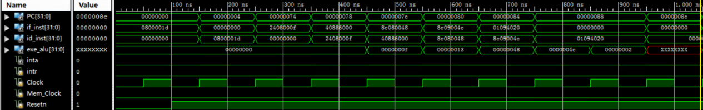

**顺利执行直到发生溢出（exe_alu为32'hxxxxxxxx）**

1. 跳转到异常处理段

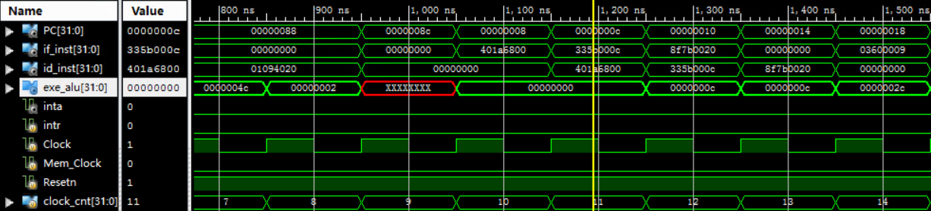

1. 成功跳转到异常处理的入口处PC = 0x8
2. 跳转到溢出处理段

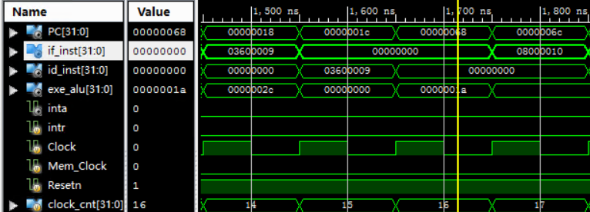

1. 成功跳转到溢出处理的入口处PC = 0x68
2. 跳转到epc_plus4段

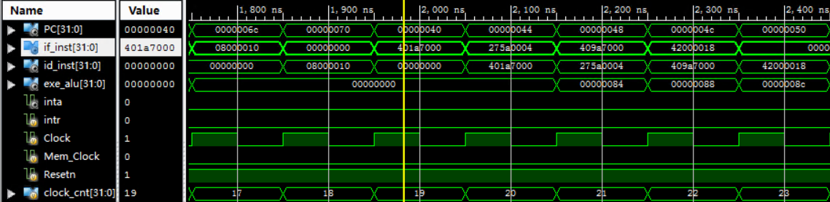

1. 成功跳转到epc_plus4的入口处PC = 0x40
2. 跳回到溢出指令的下一条指令PC = 0x88

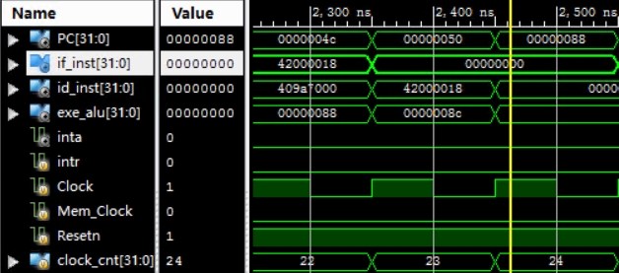

1. 成功跳转

**后续过程与溢出类似，就不再赘述过程，以下是仿真图**

2. **测试系统调用**

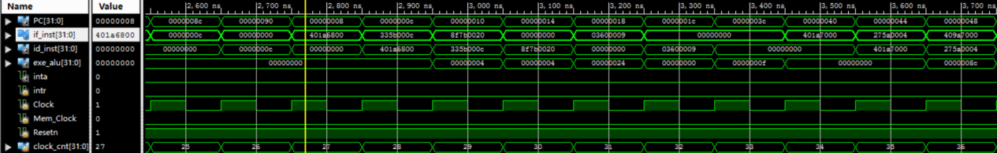

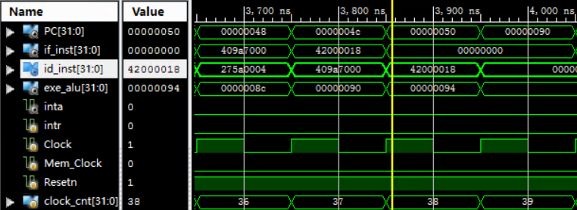

3. **测试未实现指令**

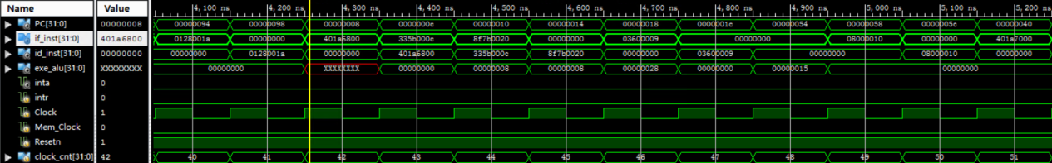

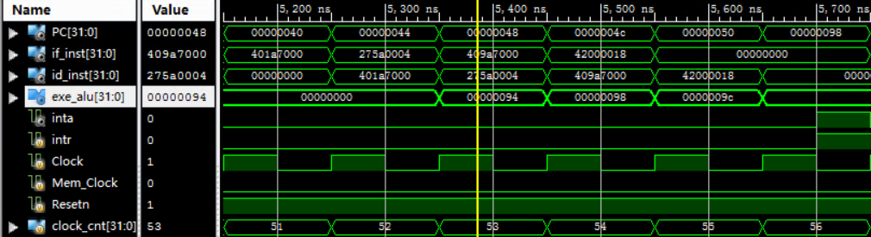

4. **测试外部中断**

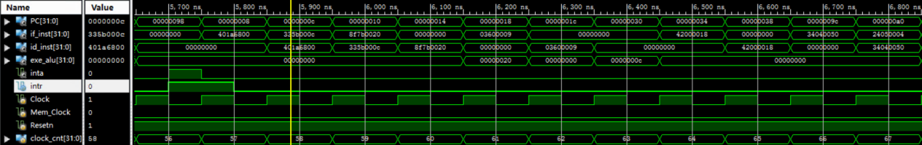

**以上仿真结果与预期相符，通过该仿真测试**